Birla Institute of Technology & Science, Pilani

Work-Integrated Learning Programmes Division

Summer Term 2022-2023

BSDCH ZC229T: Design Project
OUTLINE / ABSTRACT / PROPOSAL

Bits ID: 202117bh109
Student Name: Saipa Abhinaya
Email Address: 202117bh109@wilp.bits-pilani.ac.in
Employing Organization & Location: HCLTech, Nagpur

Mentor Name:
Email Address:
Employing Organization & Location: HCLTech, Lucknow

Design Project Title- TaskSnap Journal: A Productivity Tracker

Page 1 of 5

Content

- Broad Area of Work
- Background
- Objectives
- Scope of Work
- Plan of Work
- Particulars of Examiner and Mentor

Page 2 of 5

Broad Area of Work

The project operates within the broader domain of productivity management applications. Its focus is on addressing the challenges individuals face in managing tasks, deadlines, and overall productivity in a unified and user-friendly environment. By integrating task tracking, scheduling, and reporting functionalities, the application aims to become an all-encompassing solution for optimizing work routines.

Background

In contemporary work environments, characterized by fast-paced workflows and multitasking, the need for efficient task management has never been more pronounced. Individuals often struggle to maintain a balance between various responsibilities, leading to decreased productivity and increased stress. The project's background stems from the recognition of this challenge, emphasizing the importance of a consolidated tool that aids users in organizing their work efficiently.

As remote work and flexible schedules become increasingly prevalent, the demand for tools that transcend traditional boundaries and support individuals in managing tasks from any location rises. The project is positioned at the intersection of addressing these challenges and providing a solution that adapts to the evolving nature of work.

Objectives

- Automated Reminders: Implement a robust scheduling mechanism that automates the process of reminding users about upcoming tasks and deadlines. This feature aims to enhance time management and reduce the risk of overlooking essential assignments.

- Email Integration: Enable seamless communication by allowing users to send monthly productivity reports via email. This feature promotes transparency, facilitates collaboration, and ensures that stakeholders stay informed about individual and team accomplishments.

- Data Analysis: Provide users with insightful visual representations of their productivity trends. Charts and graphs generated from task data offer a clear overview of task completion rates, identifying areas for improvement and efficiency gains.

Page 3 of 5

Scope of Work

- Task Management: The application allows users to create, edit, and delete tasks, ensuring flexibility in adapting to evolving work priorities. Tasks can be categorized based on their complexity and priority levels.

- Scheduling: Implement a comprehensive scheduling system covering both daily and monthly tasks. Automated reminders enhance users' awareness of impending deadlines, contributing to proactive task management.

- Email Integration: Users can seamlessly send monthly productivity reports to specified recipients directly from the application. This feature enhances communication channels and supports a collaborative work environment.

- Data Visualization: The system generates graphical representations of task completion rates and productivity trends over time. Visual analytics empower users to make informed decisions about their work habits and time allocation.

- Configurability: The application allows users to configure various settings, including work hours, shift end times, and designated week-offs. This adaptability ensures that the application caters to diverse work schedules and preferences.

In summary, the project aspires to create a holistic productivity management solution that goes beyond conventional task tracking. It aims to empower users with a tool that adapts to their unique work styles, promotes collaboration, and facilitates continuous improvement in individual and team productivity.

Page 4 of 5

Plan of Work
 | Start Date-End Date | Work to be done
Outline | 13/12/23-17/12/23 | Brainstorming ideas
Design & Development | 18/12/23-20/1/24 | Developing the GUI, adding logic etc.
Testing | 21/1/24-27/1/24 | Testing the functionality of the application
Review | 28/1/24 – 6/2/24 | Complete all documentations
Submission | 7/2/24 – 10/2/24 | Uploading files to the Viva Portal

Particulars of Examiner and Mentor
 | Mentor | Additional Examiner
Name | Mahalakshmi Sivasundarasamy | Mansi Patil
Qualification | B Tech Graduate in IT | BE Graduate in CSE
Designation |  | Analyst
Employing Org^{n} and Location | HCLTech, Bangalore | HCLTech, Nagpur
Phone No.  (with STD Code) | +91 8861095242 | +91 7773943556
Email Address | mahalakshmi.sivas@hcl.com | mansi.patil@hcl.com
Signature | 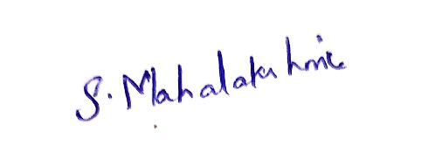 | 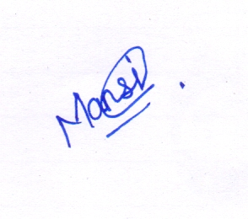
Date | 09/02/2024 | 09/02/2024

Page 5 of 5

